ECOCRIB

CASE STUDY
A14 Integrated Delivery Team, A14/M11, Cambridge to Huntingdon.

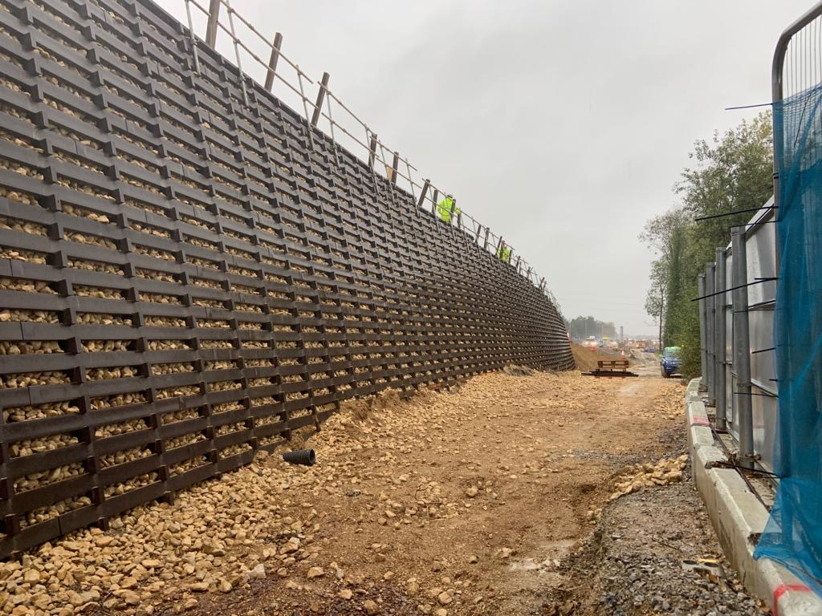
PROJECT IN

BRIEF

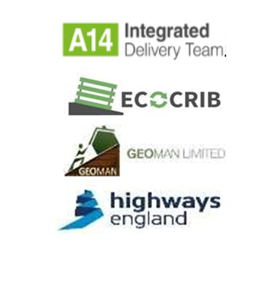
LOCATION: A14/M11 Cambridge Northern Bypass
CLIENT: Highways England
MAIN CONTRACTOR: A14 Integrated Delivery Team
ECOCRIB SYSTEM: Mass Gravity
MAX. RETAINED HEIGHT: 5.4m
FACE AREA: 1838m²
PLASTIC WASTE DIVERTED FROM LANDFILL: 212 tonnes

PROJECT IN

FULL

The Challenge
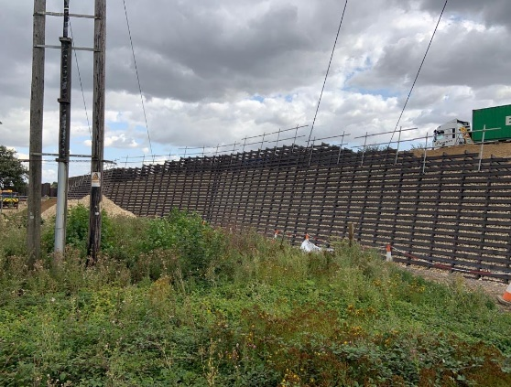
In 2015 a joint venture of Balfour Beatty, Costain and Skanksa (A14 integrated delivery team) were awarded £1.5bn by Highways England to improve the A14. These improvements included a new major 12 mile bypass, the widening of the A1 and the existing A14, improving the junctions on the A14 and building new access roads.
The A14 carries around 85,000 vehicles per day; 26% of this is HGV traffic. It is frequently congested and traffic is often disrupted by breakdowns, accidents and roadworks.
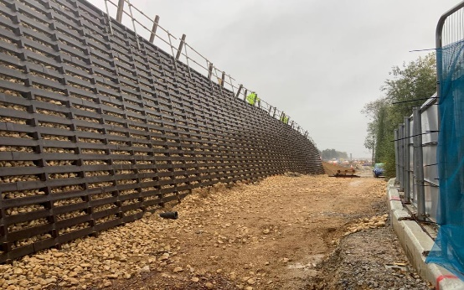
As part of the A14 major scheme a new retaining wall was needed to be constructed as new road works were encroaching on the pre-existing embankments. A durable, long lasting and low maintenance wall solution with a Highway Authorities Product Approval Scheme and British Board of Agreement (BBA) certificate was required.

The Solution
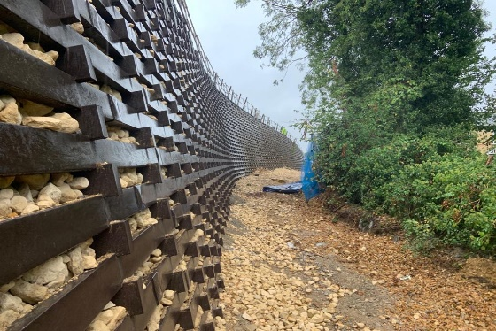
A vast number of EcoCrib mass gravity retaining walls are now constructed to support the embankments along the A14. The EcoCrib Mass Gravity Retaining Wall began its construction on 24th July and was completed 10th October 2019. With a design life in excess of 120 years, EcoCrib is durable, and the most highly sustainable retaining solution. Designed, supplied and installed by PC Construction, certified by the BBA and HAPAS in 2012.
EcoCrib profiles are manufactured entirely from recycled UK plastic (bottle tops, car bumpers etc) with any wastage or surplus material re-processed to form new EcoCrib profiles. Developed from timber crib technology, the 50mm x 125mm EcoCrib profiles are considerably more durable than treated timber but hold many of the environmental benefits.
EcoCrib can be recycled when it reaches the end of its useful life.
When considering solutions on developments of all kinds, the lifetime cost means EcoCrib is the more efficient choice.
1838 SQM of EcoCrib was used on the scheme, equivalent to 212 tonnes of plastic waste diverted from landfill.

WWW.ECOCRIBWALL.CO.UK
TUDYwwkkikik

WWW.ECOCRIBWAL
WW WWW.ECOCRIBWALL.CO.UK

